# Sprint 2 – QA Test Report

**Pod: Online Health Tracker**

**QA: Rahul Kesari**

**Date: 27-06-2025**

This report documents the QA validation of backend features for Sprint 2 of the Online Health Tracker project. The focus is on verifying API functionality for user registration and health metric submissions, as well as confirming Oracle database insertions.

## 1. Summary of Tests

* Registration Test – Passed
* Login Test – Passed
* Duplicate Email – Blocked & Logged
* Wrong Password – Blocked & Logged
* DB Insert Verified in `users` table
* Log File Verified: `logs/app-log.log`

**2. Methods/Tools Used:**

- Oracle connection configured using DBeaver.  
- Fixed foreign key mismatch by aligning UUID hash with inserted user ID.  
- Postman used to validate API endpoints.  
- Logs confirmed via Spring Boot terminal output and log files.

## 3. Postman API Tests

- Sent POST request to /api/register with valid data

- Sent POST request to /api/login with valid credentials

- Sent POST request to /api/login with invalid password

- Attempted duplicate registration with same email

## 4. Database Validation

- Used SQL query to check entries in `users` table and `health_logs table

SELECT * FROM users;

SELECT * FROM health_logs;

- Verified that no invalid/duplicate data was inserted

## 5. Log File Check

- Opened app-log.log

- Verified logs for successful and failed login/registration

## 6. Screenshots

**Screenshot 1: Postman – Registration Success:**

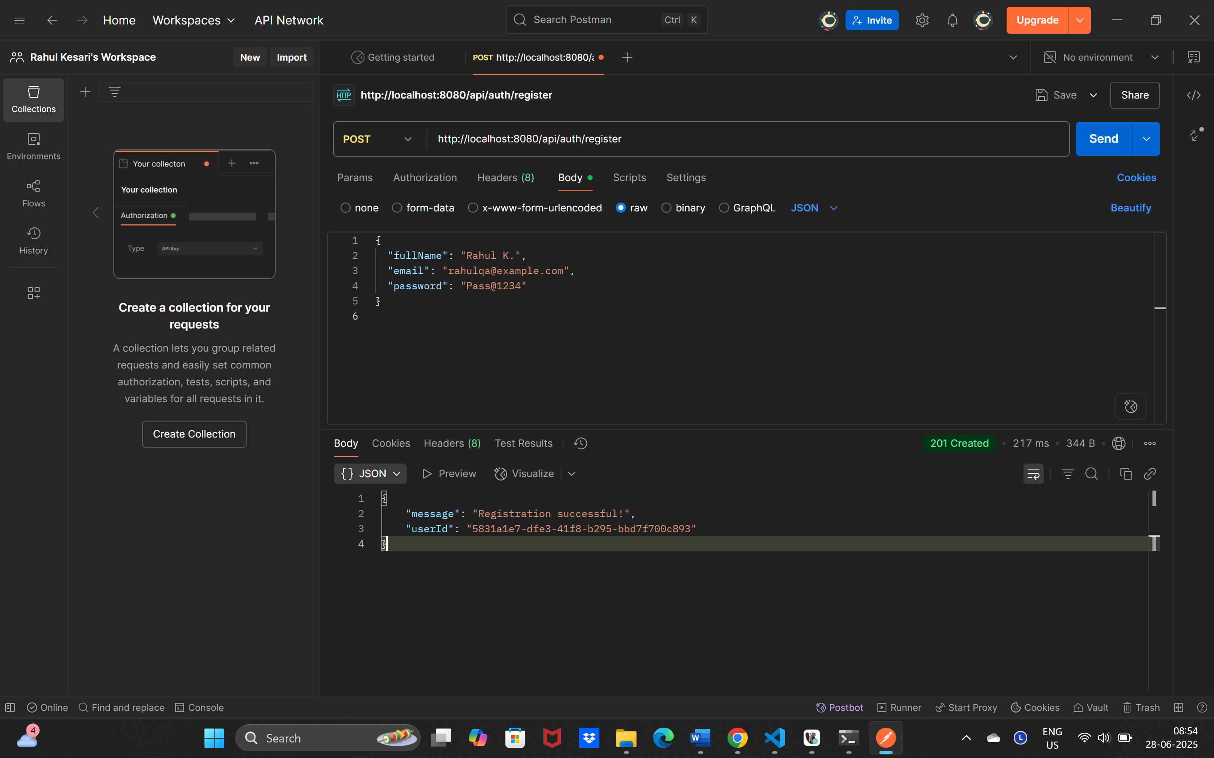

**Screenshot 2: Postman – Duplicate Registration:**

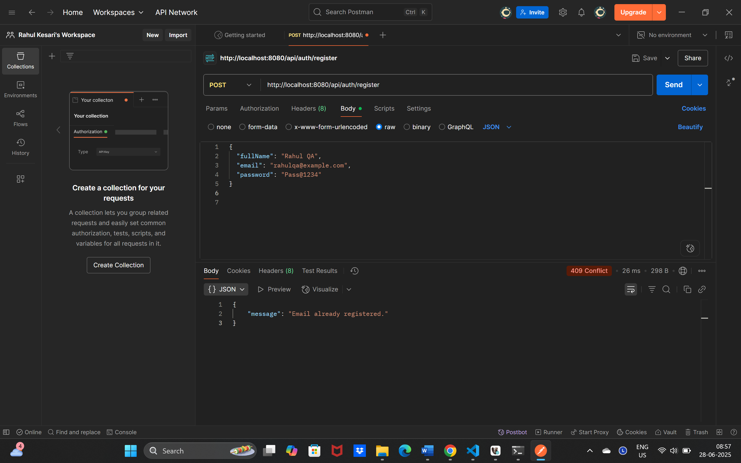

**Screenshot 3: Postman – Login Successful:**

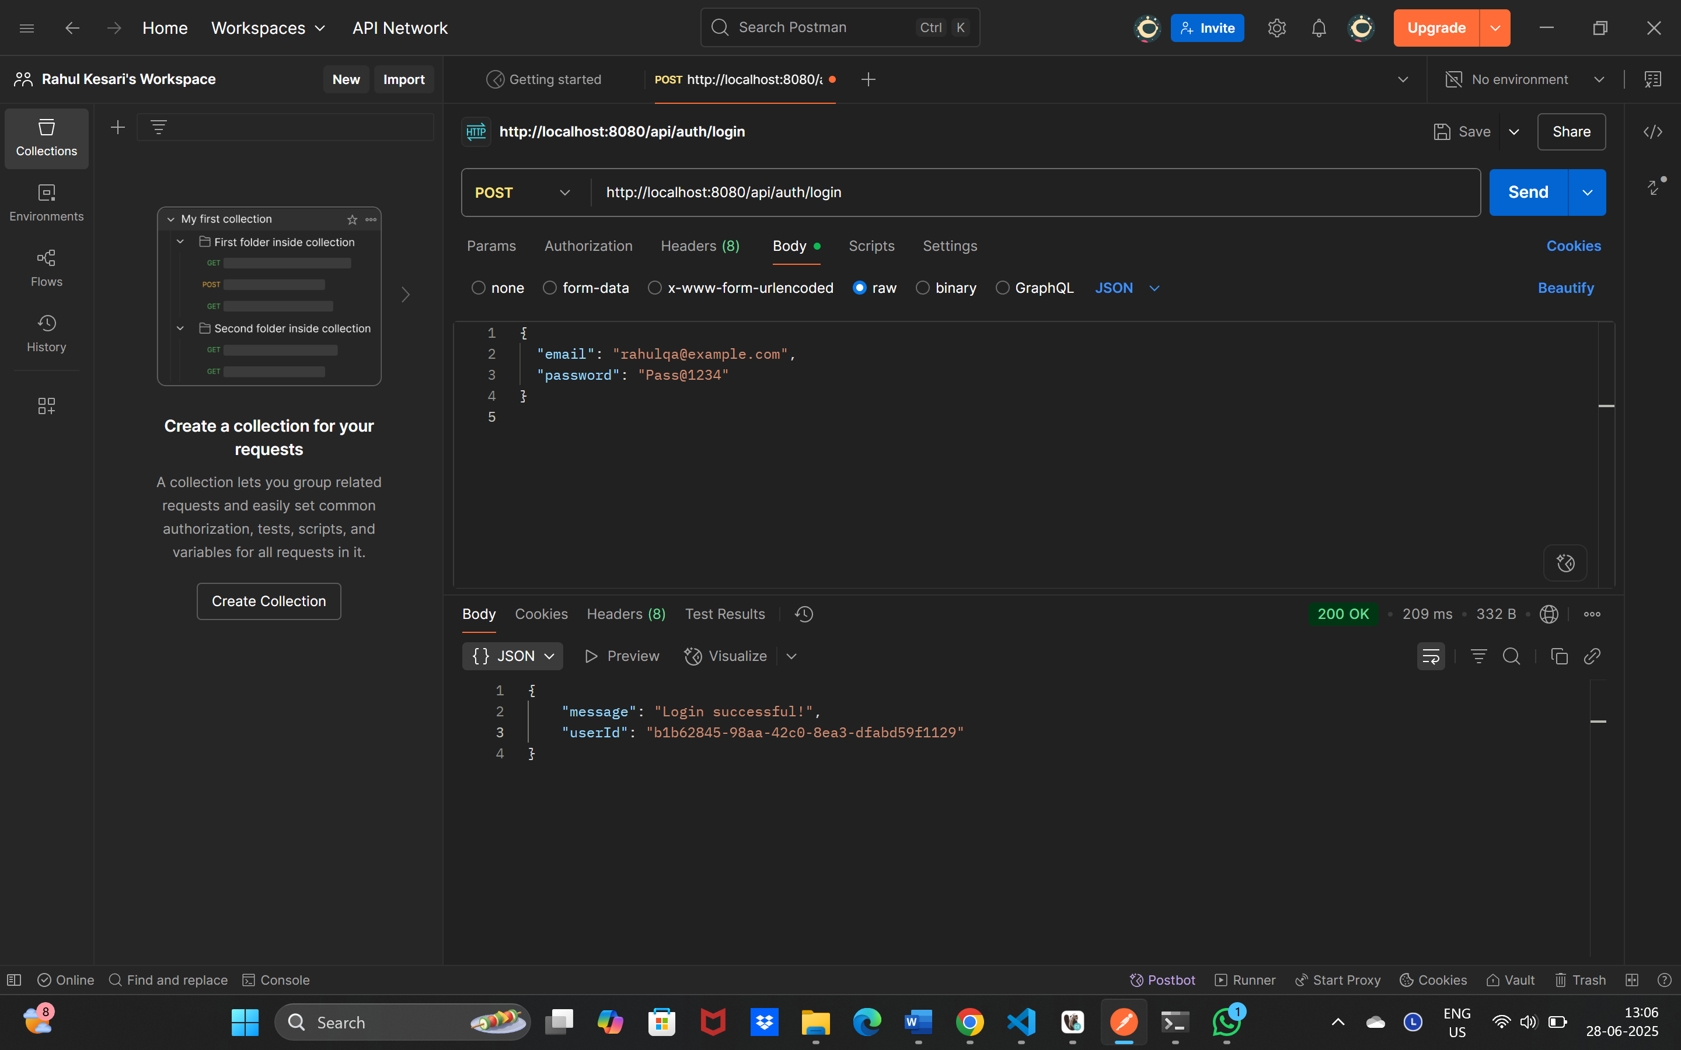

**Screenshot 4: Postman – Login Failed(Wrong Password):**

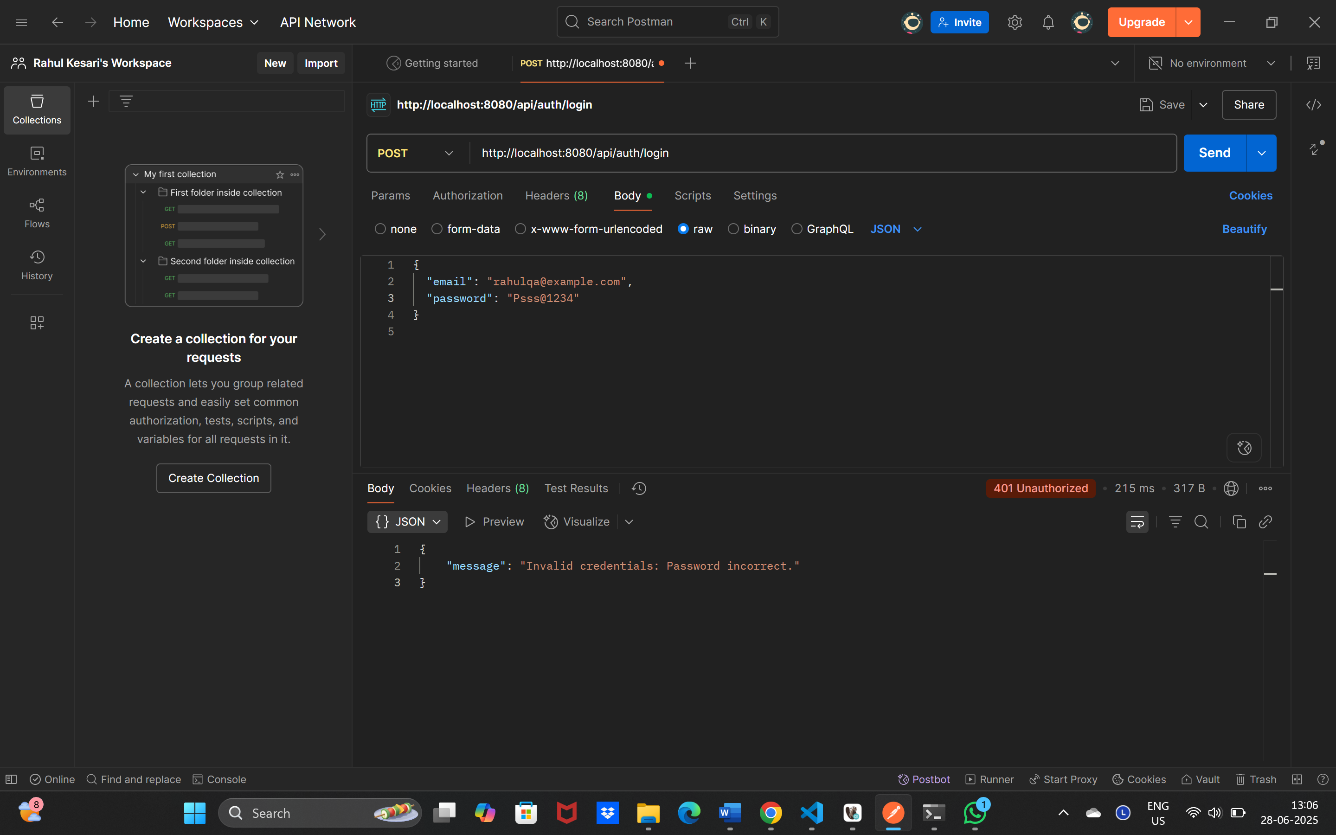

**Screenshot 5 & 6: DB query result:**

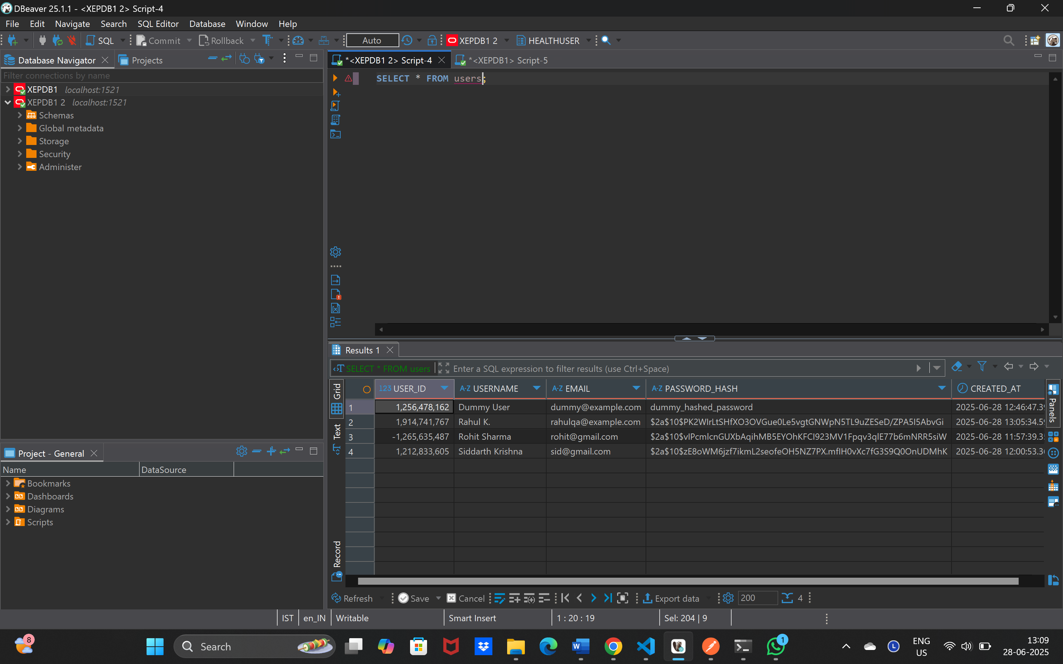



**Screenshot 7 & 8: Log file output:**

